**A Home Grown Pharmacy**

***Aloe ferox, A. arborescens*** – Bitter aloe / Kraal aloe – Aalwyn – Ikhala / Unomaweni

***Artemisia afra*** – African wormwood – Wilde als – Umhlonyane

***Bulbine frutescens*** – Stalked bulbine – Balsem kopieva – Itswele lenyoka

***Carpobrotus deliciosus*** – Sour fig – Suurvy – Igcukuma

***Helichrysum petiolare*** – Curry bush – Kooigoed - Imphepho

***Leonotis leonurus*** – Lion’s ears – Wilde dagga – Umfincafincane

***Olea europaea* subsp *cuspidata*** – Wild olive – Olienhout – Umnquma

***Seriphium plumosum*** - Silver stoebe- Slangbos –

***Tarchonanthus littoralis*** – Camphor bush – Kanferbos – Isiduli selindle / Mathola

***Vachellia karroo*** – Sweet thorn – Soetdoring – Umnga

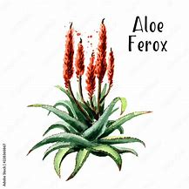***Aloe ferox, A. arborescens*** – Bitter aloe / Krantz aloe – Aalwyn – Ikhala / Unomaweni

**Family:** According to Hugh Clarke and Michael Charters,*Asphodelaceae* or “king’s spears” derives from the Greek *asphodelus*, a sceptre carried by a king or queen. Asphodel is also the name of a Mediterranean flower.

**Names:** Aloe is from the Greek for bitter, and bitter indeed is the juice from many species, but especially *Aloe ferox*! Recently, the genus has been broken down into subgroups – *Aloidendron* for the tree aloes, *Aloe* for the central body of species and *Aloiampelos* for the climbers. Popular names are generally more stable, staying the same for centuries as a rule. Krantz aloe is for the fact that *A. arborescens* has a preference for growing in the relatively water-rich, semi-shaded conditions at the foot of cliffs. Kraal for one of its traditional uses.

**Distribution:** Both these aloes are fairly widely distributed in South Africa. *Aloe ferox* stays relatively close to the Southern, Eastern Cape and Southern Natal coasts, without being a coastal species. *Aloe arborescens* hugs the Southern coast quite closely, but then occurs widely in the Eastern regions as far North as and beyond our borders. So long as soil is well drained, neither species is fussy or difficult to cultivate. *Aloe ferox* needs full sun. Most aloes are strongly drought resistant, but only some withstand any frost.

**General uses:** Krantz aloe is also called Kraal aloe because it has been commonly used to form prickly hedges around livestock byres. It is a highly decorative reinforcement for any security fence! Many aloes, especially the North African *Aloe vera*, are used worldwide in cosmetics. The international centre of this industry now is the US state of Texas. In Japan Krantz aloe, also known as Japan aloe, is processed to produce a natural skin lightener – aloesin. The leaf gel is tasteless and can be used as a skin emollient, or to make a sweet preserve rather like watermelon preserve. It is processed for inclusion in various health drinks.

**Medicinal uses:** Aloes have been used medicinally for centuries. First on record is Alexander the Great who is said to have conquered the island of Soccotra in order to gain control of the aloe trade. Aloe was needed by his armies for the treatment of digestive conditions and the wounds of war. The yellow exudate from *Aloe ferox* leaves, for example, is an anti-microbial, suitable for use as eye drops. It is also the source of the laxative/purgative Cape aloes, still in use in the pharmaceutical industry. In mixtures like “Lewensessens”the bitters function as a digestive stimulant. Japan discovered the high value of aloe gel – from *Aloe arborescens* - as a treatment for burns, including radiation burns. The colourless gel in the middle of the leaf (also *in Aloe ferox*) is cooling and emollient – excellent for sunburn and for first aid treatment of other burns. You get the gel by a process called filleting – carefully peeling away the green outer leaf covering (which contains the yellow juice) to leave you with burn dressing. You can mulch up the gel to a watery pulp if it’s easier to apply like that.

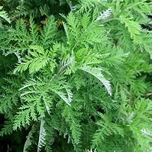***Artemisia afra*** – African wormwood – Wilde als – Umhlonyane

**Family:** *Asteraceae* – the daisy family - is one of the largest plant families, with thousands of genera and almost countless species.

**Names:** Traditional European wormwood is *Artemisia absinthum*, used, amongst other things, for flavouring the drink absinth. It’s closely related to mugwort, called *artemesie* in old Middle English, from old French, Latin and Greek roots. Mugwort has been used for centuries to induce lucid dreaming, amongst other things. Artemis was the Greek goddess of hunting and chastity, but whether she was a factor in Linnaeus’s retention of this name for the genus is not on record. Wormwood relates to an age-old medicinal use of the plant. It’s said that it’s called “als” in Afrikaans because it fixes “alles” – everything.

**Distribution:** *Artemisia afra* is widely distributed in the Eastern half of South Africa, and is found as far North as Ethiopia. It is particularly common in grassland areas. In cold winters it will die back, but regenerates in spring. In other areas it is best cut back strongly in winter.

**General uses:** In Lesotho, a largely treeless country, *Artemisia*, there called Lengana, is used as fuel for fires. It is a quite effective insect repellent and can be used in cupboards to keep away moths and fish moths. In the garden it is an attractive very fine-leaved grey-green filler shrub, growing to about 1,5 or 2,0 metres tall.

**Medicinal uses:** From the Cape peninsula to Addis Ababa, this is probably the most widely used medicinal plant in Africa. Like *Artemisia absinthum*, African wormwood contains the hallucinogenic and toxic substance, thujone. Non-stop use over long periods and/or overdose are therefore not to be recommended. The plant has scientifically demonstrated decongestant and antibacterial effects, as well as narcotic, analgesic, and antihistamine activity. This supports many of its traditional uses which include (but are not limited to) treating coughs, colds and flu as well as fever, loss of appetite, colic, headache, earache, toothache, malaria and intestinal worms. Leaves can be used fresh, sometimes simply inserted into a painful ear or blocked nose, or applied directly to a sore tooth or gumboil. They can also be infused as tea and drunk – appallingly bitter if not sweetened with honey or sugar. Alternatively, you can steam by inhaling the fumes from boiling leaves or a basin of hot water. For this purpose, *Artemisia* is often mixed with *Helichrysum* and *Tarchonanthus*. Warm compresses of umhlonyane leaves bandaged onto painful joints significantly alleviate the discomfort. The old Cape colonists often infused herbs in brandy. *Artemisia* was one such.

Sometimes the roots, known as “inyathelo” are used instead of leaves to treat colds and fever.

There is some evidence that use of *Artemisia* over time can reduce the impact of diabetes, but this raises concerns about long term effects of thujone.

Umhlonyane is my “personal medicine” – the dreamed answer to a trainee diviner’s question.

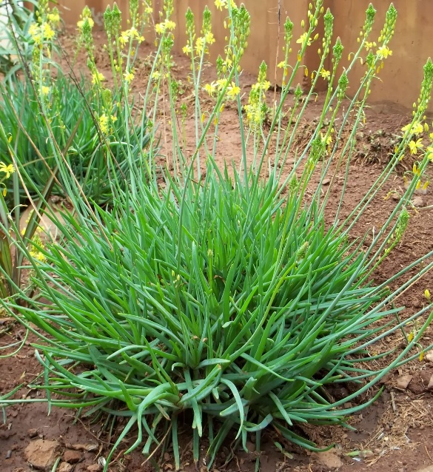***Bulbine frutescens*** – Stalked bulbine – Balsem kopiva – Itswele lenyoka

**Family:** *Asphodelaceae* – see *Aloe ferox* etc.  
According to Hugh Clarke and Michael Charters,*Asphodelaceae* or “king’s spears” derives from the Greek *asphodelus*, a sceptre carried by a king or queen. Asphodel is also the name of a Mediterranean flower.

**Names:** *Bulbine* is from the Latin *bulbus*, an onion or bulb. Actually a misnomer as the plants do not have a bulbous base at all. They have rhizomes. *Frutescens* means shrublike, and is a bit less inaccurate. *Bulbinella* (Margaret Roberts) is also wrong! The plant is also known as the burn jelly plant, alluding to one of its most common uses. Itswele lenyoka means snake’s onion.

**Distribution:** Occurs widely in the Southern and Eastern regions of South Africa, often on poor, dry, sandy or rocky soils. Will grow in full sun or partial shade, copes with drought and a limited amount of frost.

**General uses:** An attractive edging plant and groundcover in the garden. The flowers are orange or yellow and stick up above the leaves, making a nice show for long periods. The plant’s growth form is very similar to *Aloe vera*, with succulent leaves making an upward-curving bunchy rosette. Popular with landscapers.

**Medicinal uses:**  Topically: The leaf gel treats mosquito bites, burns, cuts, grazes, other wounds, rashes, itches, ringworm, boils, eczema, cracked lips, sunburn and herpes. The supposition is that the curative effects are from the chemicals in bulbine gel that are also found in *Aloe arborescens*. It’s a very Western assumption that a single chemical or compound is “the active principle” and we’re forever trying to isolate them. More recent thinking is that the unique combinations of factors that make up the whole herb may be more relevant to the healing effect.

Internally: Roots of *Bulbine natalensis, B. latifolia, B. alooides, B. ashodeloides* and *B. narcissifolia* are taken as teas for vomiting and diarrhoea and also to treat convulsions, venereal diseases, diabetes, rheumatism, urinary complaints and blood disorders. It’s true of bulbines and aloes that many different species in the genus have similar effects and can be used interchangeably. This is not always the case. In some genera, one species may be perfectly safe and another, closely related, can be deadly. You need to know who you’re dealing with!

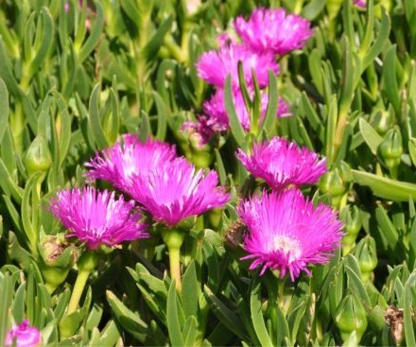***Carpobrotus deliciosus*** – Sour fig – Suurvy –Ghaukum - Igcukuma

**Family**: *Mesembryanthemaceae* – the vygie family – or is that *Aizoaecae*? Botanists seem to be obsessed with renaming and reclassifying things! At any one time each plant has only one official botanical name, and belongs to only one family, but who knows if it will be the same tomorrow? *Aizoaceae* would be a good name – from the Greek aei = ever/always and zoos/zoon = alive – alluding to the ability of the plants to live under difficult conditions.

**Names**: *Carpobrotus* from the Greek *karpos* = fruits and *brotos* = edible. *Deliciosus* = delicious. The Western Cape species *Carobrotus edulis* would then be the edible edible fruit! Sour fig? Well sweet and sour, but not strictly speaking a fig. Ghaukum is from the Khoi. Igcukuma is the local isiXhosa, but we’re still battling to find clarification of most of the names and their meanings.

**Distribution:** *Carpobrotus* species occur along an extensive mainly coastal belt from the West Coast to Natal, but any one species often has quite a limited distribution and they sometimes struggle to grow outside their niche area e.g. *C. edulis* in Bathurst. These plants have become problematic invasive weeds in areas like Cornwall, California and Western Australia.

**General uses:** This problem stems from their use as sand dune stabilisers – for which they are excellent – and fire breaks around buildings – for which they are also good if properly maintained and not allowed to develop matted woody material. An excellent and decorative ground cover for difficult, dry slopes, especially in sand. The plant needs little or no water and no maintenance beyond keeping it from spreading too enthusiastically. The fruit can be eaten fresh from the rank or dried and cooked. It’s used a lot in Cape curries, and to make sour fig jam and preserve. Some Xhosa people use the leaf juice to darken their hair.

**Medicinal uses:** The leaf juice has antiseptic (antibacterial and antifungal) properties as well as being astringent and offering a degree of pain relief. The best known use of *Carpobrotus* juice is for relief of the pain of bluebottle stings. The acid in the juice denatures the protein in the poison. Convenient that it often grows along the beach dunes! Used in conjunction with *bulbine frutescens* the juice is an effective treatment for the pain of shingles. Other topical uses include treatment of grazes and other wounds, burns, eczema, allergies, insect bites and nappy rash. The leaf juice is used as a mouthwash and gargle for the relief of oral and throat infections. Mixed with vinegar and diluted it also serves as a treatment for oral and vaginal thrush. Taken orally, sour fig has also been used to treat digestive troubles, dysentery and tuberculosis. Leaf juice is anti-diarrhoeal, but a saline drink after eating the figs acts as a purgative.

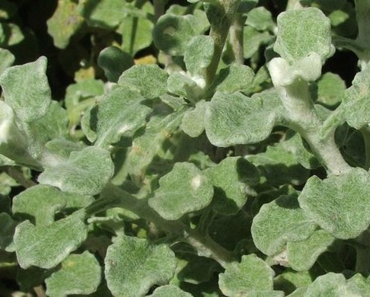***Helichrysum petiolare*** – Curry bush / Licorice plant– Kooigoed - Imphepho

**Family:** *Asteraceae* – daisy family. Cf. *Artemisia*.

**Names:** *Helichrysum* from Greek *helios* = sun and *chrysos* = gold, referring to the yellow flower heads of several species in the genus. *Petiolare* = having petioles or leaf stalks. The English names curry bush and licorice plant are applied to several species of *Helichrysum*. Both refer to the scent of the plant, particularly when exposed to warm sunlight. Also everlasting – for the papery flowers that don’t fade. Kooigoed refers to one of the old uses of the plant as bedding material – still often employed by campers. Imphepho is for the use of several *Helichrysum* species as a smudge or ritual incense. One or two non-helichrysum species are also used as imphepho, e.g. *Achyrocline stenoptera*.

**Distribution:** At least four species of *Helichrysum* are widely used as imphepho. They are:   
*H. nudifolium, H. petiolare, H. cymosum* and *H. odoratissimum*. Between them they cover a large proportion of South Africa, sometimes in somewhat specialist niches. There are about 600 species of *Helichrysum* worldwide, and about 245 in Southern Africa. At least a dozen species are extensively used medicinally. *H. petiolare,* originally from the Southern Cape, has become invasive in several countries, including Portugal and California.

**General uses:** In the garden the silvery grey silk-covered leaves of the aromatic *Helichrysums* are very attractive, enhanced seasonally by the mainly yellow or creamy flower heads, often strongly honey scented and attractive to bees. The plants have insecticidal and insect repellent properties and soft branches, so they make excellent bedding that repels ticks and mosquitoes. The scent is also soporific, further enhancing the chances of a good night’s sleep. As a fumigant, the smoke from smouldering smudges disinfects sickrooms. But the major use of imphepho is in ritual – to ward off evil, to attract the attention of the ancestors, to calm the spirit, to facilitate achievement of trance or trance-like states resulting from its mild psychoactive properties. Fresh leaves and stems are plaited into lengths and then broken to the desired size for burning when dry. Sometimes one or more other herbs are plaited into these “smudge sticks” to enhance the psycho-active effect.

**Medicinal uses:** Mainly leaves, stems and, in season, flowers, are used. Fresh if available, dry if not. These herbs have anti-oxidant, antiseptic (anti-microbial and anti-fungal) qualities, as well as being anti-inflammatory and giving relief of pain. For headaches, colds, flus and fevers (including tick-bite fever), an infusion is normally drunk and/or used as a steam bath to clear the respiratory tract. It may also be drunk as a soporific. Cooled, such an infusion might be used as an antiseptic wash for rashes or other skin conditions. Warm or cold compresses made from boiled-up leaves and stems are used as a wound dressing to prevent or relieve inflammation – *H. pedunculare* is particularly popular for dealing with circumcision wounds.

See also *Helichrysum auriculatum, H. crispum, H. foetidum, H. nudifolium, H. patulum, H. pedunculare, H. splendidum, and H. stenopterum.*

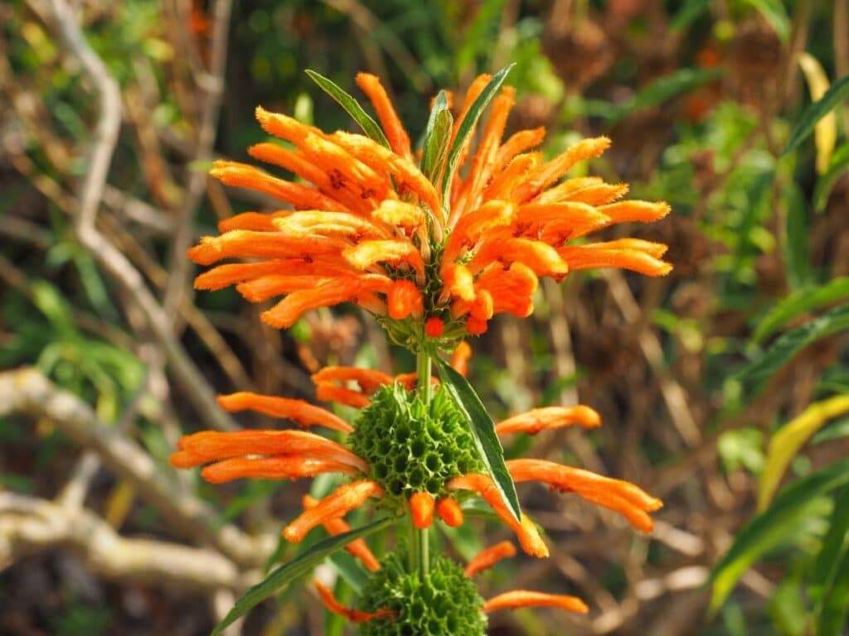***Leonotis leonurus*** – Lion’s ears – Wilde dagga – Umfincafincane

**Family:** *Lamiaceae* – the mint family. Plants in this family often have four-angled stems and slightly furry leaves. They are often also medicinal.

**Names:** *Leonotis* from the Greek leon = lion and ous, otis = ear. Like lion’s ears in shape, colour or texture??? *Leonotis leonurus* simply repeats the concept in both halves of the name. Wild/e dagga? It is only mildly narcotic and reputedly very unpleasant to smoke. For umfincafincane we have not yet found an interpretation. One Xhosa igqirha said that this is the name of another *Leonotis* species, milder in its action and suitable for use with children, where *Leonotis leonurus* is “too strong”.

**Distribution:** Widely distributed along the Cape coast and generally also more inland in the Eastern parts of South Africa. Other species of *Leonotis* extend the range considerably.

**General uses:** Several species of *Leonotis* have similar uses. These are very decorative garden shrubs – an enthusiastic green with characteristic flowering stems – minaret flower - brightening the garden for a long season. Sunbirds and other nectar eaters are attracted in numbers to the flowers, as are various insects, which in turn attract other birds. Tough, waterwise and frost resistant. They die down in winter but regenerate. Leaves have an insect repellent quality, for example in pot pourri. There are many uses in traditional veterinary medicine, mostly for the treatment of wounds and skin lesions. Some traditionalists sprinkle a decoction of *Leonotis leonurus* around their houses “to keep snakes away”. These are not normally your actual creepy crawlies, but more usually ill-intentioned people and general evil forces. Many of the plants used in this way do in fact have antiseptic effects!

**Medicinal uses:** Roots and sometimes other parts of the plants are widely recorded as being used by indigenous South Africans in the treatment of snakebite. What is never indicated is what kind of snake, nor how effective the remedy might have been. The venom of our major species of dangerous snake differs significantly in its effects, and therefore in the treatment required. Cobras and mambas have neurotoxic venom that affects the central nervous system and suppresses breathing. Boomslang venom is haemotoxic, affecting the blood’s clotting ability. Puffadder venom is cytotoxic, rotting away the flesh at the site of the bite. This is the most common of South African snakebites because the snakes like to lie on paths in the sun and are notoriously lazy about moving out of the way of passers-by.

If not smoked recreationally, *Leonotis* has been smoked for relief of epilepsy. Branches added to bathwater are an excellent treatment for itchy skin conditions like eczema. Other external applications include treatment of boils, other skin diseases and muscular cramps. Leaf infusions also treat colds, flu, coughs, bronchitis, headaches, asthma and high blood pressure. The plant contains the same compounds as the European white horehound (*Marrubium vulgare*) which has long been used as a cough remedy. *Leonotis* species are also used to treat menstrual problems, and occasionally as an abortifacient.

See also *Leonotis ocymifolia* and *L. nepetifolia*

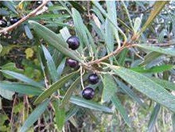***Olea europaea* subsp *cuspidata (*** formerly ***africana)*** – Wild olive – Olienhout – Umnquma

**Family:** *Oleaceae* – olive, privet and jasmine family. Scores of genera and several hundred species. We have four species of olive in South Africa.

**Names:** *Olea* is the ancient Latin name for olive fruit and tree. *Europaea* = from Europe, on the assumption that the cultivated olive is the key type! Probability is that the wild olive is the original ancestor. *Cuspidata* – having a sharp tip - .i.e the leaves. *Africana* = from Africa. Its current scientific name is the seventh in its history. Afrikaans has at least 17 names for this tree. English only 5! In isiXhosa it is almost always called Umnquma, occasionally Umncuma or Umquma. Most of the names relate either to the fruit or the extreme hardness of the wood.

**Distribution:** Throughout South Africa, Eastern and North Africa, Western Asia, Indian sub-continent and Western China. In reasonable conditions it is an attractive round-crowned tree, very long lived. In tough situations it may be a stunted shrub. With roots that will go down as much as 7 metres, it survives drought easily, also frost to -5 degrees, and wind.

**General uses:** Fodder for livestock and game – leaves and fruit. Leaves brewed as tea. Garden ornamental – escaped in Australia to become a weed. Attracts wide range of wildlife to the garden. Bonsai. Graft stock for commercial olives. Wood – furniture, turnery, fighting sticks, digging sticks, fence posts (termite and borer resistant). Twice as hard as oak! Ink can be made from the juice of the ripe fruit. Fruit is edible, though the taste varies from tree to tree, and will yield oil. Symbolic or sacred tree in many cultures – e.g. peace in ancient Greece, wisdom in Africa. Essential element in Xhosa sacrificial ceremonies.

**Medicinal uses:** Leaf extract, fruit and oil have a vast number of medicinal uses. These are some of the established qualities found in them: hypolipodemic (therefore anti-artherosclerotic), hypoglycemic (therefore anti-diabetic), antioxidant, antiviral, antimicrobial. The benefits of use include lowered blood pressure, as well as reduced risk of coronary disease and some cancers though some studies indicate that long term use especially in high doses can result in some liver and/or kidney damage. I’ve been using olive leaf continuously since the late 1990’s, without any side effects so far.

Oil of seeds is laxative. Leaf extract helps control diarrhoea. Oil and lemon juice are used for gallstones. It is thought that the lower-than-average rates of heart disease and obesity in Mediterranean countries may be largely due to the widespread use of olive oil in salads and cooking, and for moistening bread.

A leaf infusion or decoction can be used as an eye lotion, also for coughs, colds, flu and sore throat. The antiseptic effects also treat urinary tract infections. The infusion reduces inflammation and boosts immunity. Olive leaf extract can be used in a weight control regime as it helps the body resist weight gain.

The immune boosting and antiviral properties might be useful in the context of covid!

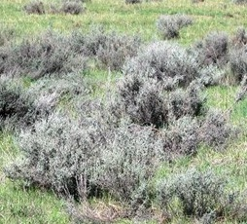***Seriphium plumosum*** - Silver stoebe- Slangbos –

**Family:** *Asteraceae*. See *Artemisia afra*.

**Names:** Until recently *Seriphium plumosum* was three separate species of *Stoebe* – *S. cinerea, S. plumosa* and *S. vulgaris*. The three species didn’t behave identically, nor were they used identically, but now they have been botanised into a single unit! *Seriphium* is from seriph, the typesetting term referring to the “tail” on letters in typefaces like Times New Roman – a projecting knob, for the way the branchlets grow out from the branches. *Stoebe* is for packing material, one of the uses of the plants. Who knows why Slangbos. And we’re still looking for the isiXhosa name. This may be a grassland plant from just West of the area originally inhabited by the amaXhosa. *Plumosa* and *plumosum* are both for the feathery quality of the leaves.

**Distribution:** *Stoebe vulgaris* is mainly from the Northern and Northwestern Cape where it is developing a bad reputation for “bush encroachment” – invading areas that have been over-grazed. Stock do not eat it. One of its popular names is “bankrot bos” – either because it indicates the inevitable result of bad farming practice, or as a predictor of a bad outcome.

*Stoebe cinerea* and *S. plumosa* are very common in the Western Cape, but not problematic in fynbos. They are grazed only when young.

**General uses:** This is a woody shrublet with soft, hairy (or feathery) branchlets and leaves – excellent for stuffing pillows and as campers’ bedding. Some sources suggest “Khoi kooigoed” as a name, perhaps indicating that use as bedding is ancient. It may also indicate that the plant has insect repellent properties, although these are not on record.

In the garden, this is an interesting small grey filler shrub (1m x 1m). It is often used as such in the Kirstenbosch exhibit at the prestigious Chelsea Flower Show in London. It makes a striking and long lasting addition to a flower arrangement.

**Medicinal uses:** *Stoebe vulgaris* is not recorded as having medicinal uses. *Stoebe plumosa* is similarly not on record for medicinal use, but has been and is a widely used and very effective anti-diarrhoeal. *Stoebe cinerea* is recorded as being used as a “remedy for heart trouble”. What kind of heart trouble is not specified!

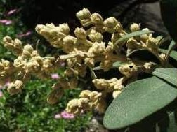***Tarchonanthus littoralis*** – Camphor bush – Kanferbos – Isiduli selindle / Mathola

**Family:** *Asteraceae*. See *Artemisia afra*.

**Names:** *Tarchonanthus* from Greek *tarchos* = funeral rite and *anthos* = flower. Presumably for the camphor like smell of the leaves as used in incense sticks in places of worship. *Littoralis* = fringe or coastal, for its distribution. Until recently what are now five separate species were lumped together as one – *Tarchonanthus camphoratus*. Camphor bush and Kanferbos both refer to the characteristic smell of the leaves. The Afrikaans name Vaalbos, reflects the general colour of the plant, especially the inland species.

**Distribution:** The undifferentiated species *Tarchonanthus camphoratus* was/is very widely distributed throughout Southern Africa and much of East Africa. *Tarchonanthus littoralis* is essentially a coastal species, roughly following the coastline from the Western Cape through to KZN. It’s a very tough tree, surviving wind, heat, drought and frost with equal ease.

**General uses:** The wood is hard and fine and has been used for musical instruments. It makes excellent firewood and durable fence posts. Leaves have been smoked as a dagga substitute for their narcotic qualities; smoked in a pipe they are sedative. Smoke from burning leaves also fumigates living areas. Leaves are insect repellent and will keep cupboards bug free, also rubbed into the scalp, will keep nits away. Fluffy seed heads have been used to stuff pillows and are said to give a good night’s sleep. Some cultures use *Tarchonanthus* as a perfume. Another traditional use is to chew leaves as a protection against evil forces, especially if one is in a strange place. It has no thorns, but injuries from *Tarchonanthus* splinters heal with difficulty.

**Medicinal uses:** Mainly the leaves are used, usually either infused in hot water like tea or simply chewed raw. Most of the uses relate to the “opening-up” ability associated with the camphor smell – asthma, bronchitis, coughs, colds, flu. *Tarchonanthus* is also often used as a steaming substance, often with *Artemisia afra* and *Helichrysum* in a basin of hot water. There is a pain relieving capacity demonstrated by its use for rheumatism, headache and toothache, as well as digestive effects relating to the treatment of heartburn and indigestion. It has also been used to relieve anxiety, perhaps for the same qualities that ensure a good night’s sleep on *Tarchonanthus* pillows.

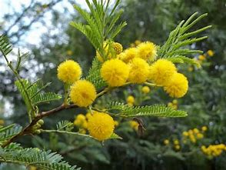***Vachellia karroo*** – Sweet thorn – Soetdoring – Umnga/Umga

**The family:**  *Fabaceae*, pea and bean family, is huge and subdivided into subfamilies. One of these is *Mimosaceae*, the thorn tree family. All Fabaceae have the ability to fix nitrogen in the soil, thereby rendering it more fertile for other plants and crops – e.g. alternating maize with soya beans.

**The name:** Any book published before 2011 will show this tree under the name *Acacia Karroo*. *Acacia* is from the Greek *akis* for thorn. Then Australian botanists mounted a campaign to have the genus revised. Amidst much furious protest, everyone else’s thorny *Acacias* were renamed but several hundred thornless Australian species retained the name. *Vachellia* is after a nineteenth century French politician and entomologist Joseph Vachal. *Karroo* is an old spelling of Karoo, but the rules of botanical nomenclature forbid simply updating it.

Sweet thorn / Soetdoring possibly because gum exuding from wounded bark is sweet, or because the puffball yellow flowers are sweetly scented in summer. Great as a Xmas tree!

**Distribution:** Very widely distributed in South and Southern Africa, except the Western desert areas. Survives in almost any soil, but does best in deep riverside silt. Frost, heat and drought resistant.

**General uses:** Brilliant braai wood – hot, long lasting coals – and great in an open fireplace. Good fodder plants. Animals eat leaves, pods and seeds. The flowers are important in the production of honey and as a protein rich food for birds and monkeys. Bark has been used in tanning and a bark infusion is given to cattle as an antidote to some kinds of poisoning. Inner bark makes a reliable rope. Clear golden gum is edible and has been used in pharmaceuticals, confectionery and as glue. It used to be exported as “Cape Gum” for use instead of gum arabic. Seeds have been roasted and used as a coffee substitute. Indicates fertile soil and good grazing - umnquma, umthathi, umnga and umnqayi. May also signal underground water.

Bush encroachment. *Vachellia karroo* is a pioneer plant – able to establish itself in full sun without support from surrounding plants. In over-grazed areas, particularly grassland, this characteristic is a problem, resulting in so-called “bush encroachment”.

**Medicinal uses:** Gum, leaves, bark and roots are used for various things. The gum is an effective treatment for oral thrush. Gum, bark and leaves have been used as an emollient and astringent for colds, ophthalmia, and haemorrhage. Leaves and/or bark infused like tea are a treatment for diarrhoea and were in the past also used for dysentery. A decoction of the bark is a Zulu emetic “to expel any deleterious matter arising from the activity of a witch or other evil person”. Crushed roots in babies’ food relieve colic.

Dysentery – gastro-intestinal infection resulting in cramps, low grade fever and bloody stools – is caused by either amoeba or, more generally, several kinds of Shigella bacteria. Current treatment is by anti-amoebic drugs and anti-biotics, but the bacteria are showing signs of developing resistance. This is resulting in serious research into plant-based traditional treatments, for this and other diseases.

**Main References**

Ben-Erik van Wyk, Bosch van Oudtshoorn, Nigel Gericke, 2000, ***Medicinal Plants of South Africa***, Briza. 304 pages of locally relevant stuff. Very scientific.

Ben-Erik van Wyk and Nigel Gericke, 2000***, People’s Plants, a Guide to Useful Plants of Southern Africa***, Briza. 351 pages of fascinating, wide-ranging information.

Ben-Erik van Wyk and Gideon Smith, 2003, ***Guide to the Aloes of South Africa***, Briza.  
304 pages of illustrated field guide.

Francis W Fox and Marion E Norwood Young, 1982***, Food from the Veld, Edible Wild Plants of Southern Africa***, Delta Books. 400 pages summarising mainly documentary detail.

Hugh Clarke and Michael Charters, 2016, ***The Illustrated Dictionary of Southern African Plant Names***, Jacana. 478 pages of explanation of scientific names of Southern African plants.

John M Watt and Maria G Breyer-Brandwijk, 1962***, Medicinal and Poisonous Plants of Southern and Eastern Africa*,** E & S Livingstone Ltd. 1457 pages of meticulous documentary research.

Margaret Roberts, 1990, ***Indigenous Healing Plants***, Southern Book Publishers. 285 pages of chatty writing that includes interesting anecdotes and culinary recipes.

Meg Coates Palgrave, 2002, ***Keith Coates Palgrave Trees of Southern Africa***, Struik. 1212 pages dealing with every tree in the region, the only book that does.

Richard Boon, 2010***, Pooley’s Trees of Eastern South Africa***, Flora and Fauna Publications Trust.  
625 pages covering all trees in KZN, the former Transkei, and most of the Eastern Cape.

Various websites, principally SANBI’s PlantZAfrica and Kumbula Indigenous Nursery.